The template

This document provides the business case template for projects seeking funding which is made available through the South East Local Enterprise Partnership. It is therefore designed to satisfy all SELEP governance processes, approvals by the Strategic Board, the Accountability Board and also the requirements of the Independent Technical Evaluation process where applied.
It is also designed to be applicable across all funding streams made available by Government through SELEP. It should be filled in by the scheme promoter – defined as the final beneficiary of funding. In most cases, this is the local authority; but in some cases the local authority acts as Accountable Body for a private sector final beneficiary. In those circumstances, the private sector beneficiary would complete this application and the SELEP team would be on hand, with local partners in the federated boards, to support the promoter.
Please note that this template should be completed in accordance with the guidelines laid down in the HM Treasury’s Green Book. https://www.gov.uk/government/publications/the-green-book-appraisal-and-evaluation-in-central-governent

Version control
Document ID
Version
Author
Document status
Authorised by
Date authorised

- PROJECT OVERVIEW

  - Project name:
[Specify the name of the scheme, ensuring it corresponds with the name of the scheme at programme entry (when added to the GBF prioritised list of projects or other shortlisting process).]

  - Project type:
[Road, rail, LSTF, integrated package, maintenance, etc.]

  - Federated Board Area:
[East Sussex, Kent & Medway, Essex, and South Essex]

  - Lead County Council / Unitary Authority:
[East Sussex, Kent, Medway, Essex, Thurrock, Southend-on-Sea]

  - Development location:
[Specify location, including postal address and postcode.]

  - Project Summary:
[Provide a summary of the project; max. 0.5 pages.]

  - Delivery partners:
[List all delivery partners and specify the lead applicant and nature of involvement, as per the table below.]

Partner | Nature of involvement (financial, operational etc.)
Lead Applicant

  - Promoting Body:
[Specify who is promoting the scheme.]

  - Senior Responsible Owner (SRO):
[Specify the nominated SRO and provide their contact details. The SRO ensures that a programme or project meets its objectives and delivers projected benefits. This is not the same as a Section 151 Officer.]

  - Total project value and funding sources:
[Specify the total project value, how this is split by funding sources, and any constraints, dependencies or risks on the funding sources, as per the table below.]

Funding source | Amount (£) | Constraints, dependencies or risks and mitigation
Total project value

  - SELEP funding request, including type (LGF, GPF, GBF etc.):
[Specify the amount and type of funding sought from SELEP to deliver the project. Please also confirm that the funding will not constitute State Aid.]

  - Exemptions:
[Specify if this scheme business case is subject to any Value for Money exemptions (and provide details of these exemptions) as per the SELEP Assurance Framework 2020, Section V3.3]

  - Key dates:
[Specify dates for the commencement of expenditure, the construction start date and the scheme completion/opening date.]

  - Project development stage:
[Specify the project development stages to be funded, such as inception, option selection, feasibility, outline business case, detailed design, procurement, full business case, implementation, the current project development stage, and a brief description of the outputs from previous development stages. Add additional rows as necessary. Please note, not all sections of the table may require completion.]

Project development stages completed to date
Task | Description | Outputs achieved | Timescale
Project development stages to be completed
Task | Description |  | Timescale

  - Proposed completion of outputs:
[Include references to previous phases/tranches of the project (link to the SELEP website) and to future projects to be funded by SELEP.]

- STRATEGIC CASE

The Strategic Case should present a robust case for intervention and demonstrate how the scheme contributes to delivering the SELEP Economic Recovery and Renewal Strategy and SELEP’s wider policy and strategic objectives. It includes a rationale of why the intervention is required, as well as a clear definition of outcomes and the potential scope for what is to be achieved.

The outlook and objectives of the Strategic Case should, as far as possible, align with the Monitoring and Evaluation and Benefits Realisation Plan in the Management Case.

  - Scope / Scheme Description:
[Outline the strategic context for intervention by providing a succinct summary of the scheme, issues it is addressing and intended benefits; max. 2 pages.]

  - Logic Map
[Establish a Logic Map using information from Appendix D. This will provide a logical flow between inputs, outputs, outcomes and impacts for the scheme]

Inputs | Outputs | Outcomes | Impacts
For all schemes:  Take from section 1.10 / Financial Case  Grant Spend  £xxxm  Matched Contributions Spend  £xxxm  Leveraged Funding  £xxxm | For all schemes:  Influenced by detail in section 3.2.  Also refer to metrics output metrics within Appendix D | Influenced by details in sections 2.1, 3.4, 3.5, 3.10  For schemes of £2m of funding or less:  -Jobs  -Houses  For schemes £2m-£8m:  Include all required LEP metrics shown in Appendix D:  M&E Metrics for scheme type (skills, land/property/flood protection, business support/innovation/broadband, transport) plus any moderate or large benefits/disbenefits which occur as part of section 3 in this template  For schemes more than £8m:  Include all required LEP M&E Metrics and consider further metrics within Appendix D plus any moderate or large benefits/disbenefits which occur as part of section 3 in this template | For schemes of £2m of funding or less:  -n/a  For schemes £2m-£8m:  -Relevant impacts from Appendix D plus any moderate or large benefits/disbenefits which occur as part of section 3 in this template  For schemes more than £8m:  -Relevant impacts from Appendix D plus any moderate or large benefits/disbenefits which occur as part of section 3 in this template

  - Location description:
[Describe the location (e.g. characteristics, access constraints etc.) and include at least one map; max. 1 page excluding map.]

  - Policy context:
[Specify how the intervention aligns with national/regional/local planning policies and the SELEP Economic Recovery and Renewal Strategy; max. 3 pages.

Smaller schemes: (less than £2 million) are required to complete this section in line with the scale of the scheme; max. 1 page]

  - Need for intervention:
[Specify the current and future context and articulate the underlying issues driving the need for intervention referring to a specific market failure, need to reduce externalities, Government redistribution objectives etc.; max. 2 pages.]

  - Sources of funding:
[Promoters should provide supporting evidence to show that:
- all reasonable private sector funding options have been exhausted; and
- no other public funding streams are available for or fit the type of scheme that is being proposed.

Public funding is regarded as a last resort. Promoters are encouraged to think carefully about and provide strong evidence that the intervention they are proposing has exhausted all other potential sources of funding and there is a genuine need for intervention from the public sector; max. 1.5 pages.]

  - Impact of non-intervention (do nothing):
[Describe the expected outcome of non-intervention. Promoters should clearly establish a future reference case and articulate the impacts on environment, economy and society, if applicable. The future reference case should acknowledge that market conditions are likely to change in the future, with or without any intervention. ‘Do nothing’ scenarios where nothing changes are unlikely; max. 1 page.]

  - Objectives of intervention:
[Outline the primary objectives of the intervention in the table below and demonstrate how these objectives align with the problems presented in the Need for Intervention section.]

Project Objectives (add as required)

Objective 1:
Objective 2:

Problems or opportunities the project is seeking to address (add as required)

Problem / Opportunity 1:
Problem / Opportunity 2:

[Complete the following using a system of 0, , ,  which maps the objectives to their ability to address each problem. Add rows and columns as required and note not all sections of the table may require completion; max. 1 page.]

 | Problems / opportunities identified in Need for Intervention section
 | Problem / Opportunity 1 | Problem / Opportunity 2 | Problem / Opportunity 3
Objective 1 | e.g. 
Objective 2 |  |  | e.g. 0
…

  - Constraints:
[Specify high level constraints or other factors such as social/environmental/ financial/developments/schemes/legal consents and agreements which may affect the suitability of the Preferred Option; max. 0.5 page.]

  - Scheme dependencies:
[Provide details of any related or interdependent activities that if not resolved to a satisfactory conclusion would mean that the benefits of the scheme would not be fully realised; max. 0.5 page.]

  - Expected benefits:
[This section identifies scheme benefits (which will be achieved through delivering the scheme) which may not be valued in the Economic Case. Specify the extent of the scheme benefits referring to relevant economic, social, environmental, transport or other benefits. This is where any ‘GVA based’ estimates of benefits should be reported together with any dependent development (e.g. commercial or residential floorspace). Please reference the relevant section of the Economic Case where additional information regarding the assessment approach can be found; max. 0.5 page.]

  - Key risks:
[Specify the key risks affecting delivery of the scheme and benefit realisation e.g. project dependencies, stakeholder issues, funding etc. Information on risk mitigation is included later in the template. This section should be kept brief and refer to the main risk register in the Management Case; max. 0.5 page.]
- ECONOMIC CASE

The economic case determines whether the scheme demonstrates value for money. It presents evidence on the impact of the scheme on the economy as well as its environmental, social and spatial impacts in terms of how well they meet the spending objectives and critical success factors for the scheme.

In addition to this application form, promoters will need to provide a supporting Appraisal Summary Table (AST). This should provide:

- a calculation of Benefit-Cost Ratio (BCR) according to the most recent Government WebTAG transport analysis guidelines, with clearly identified, justified and sensitivity-tested assumptions and costs (please see Transport Analysis Guidance: WebTAG and
- inclusion of optimism bias and contingency linked, where appropriate, to a quantified risk assessment (please see Green Book supplementary guidance: optimism bias).

Smaller schemes (less than £2 million) are not required to provide a supporting AST, and do not have to calculate a BCR.

  - Options assessment:
[Outline all options that have been considered, the option assessment process, and specify the rationale for discounting alternatives.

Promoters are expected to present a sufficiently broad range of options which avoid variations (scaled-up or scaled-down version) of the main options. The key to a well scoped and planned scheme is the identification of the right range of options, or choices, in the first instance. If the wrong options are appraised the scheme will be sub-optimal from the onset.

Long list of options considered:
Description of all options which have been considered to address the problem(s) identified in the Need for Intervention section above, including options which were considered at an early stage, but not taken forward.

Options assessment:
Describe how the long list of options has been assessed (assessment approach), rationale behind shortlisting/discarding each option.

Short list of options:
The ‘Options Assessment’ section is an opportunity to demonstrate how learning from other projects and experience has been used to optimise the proposal, and the Preferred Option is expected to emerge logically from this process; max. 2 pages.

Smaller schemes (less than £2 million) are required to complete an Options assessment which is proportionate to the size of the scheme; max. 1 page.]

  - Preferred option:
[Describe the Preferred Option and identify how the scheme aligns with the objectives. Include evidence of stakeholder support for the Preferred Option either through consultation on the scheme itself or on the strategy the scheme forms part of; max. 1 page.]

  - Assessment approach:
[Describe the approach used to assess the impacts of the scheme, describing both the quantitative (including reliability if appropriate) and qualitative approaches used. Describe the reference case (‘Do nothing’) and the Preferred Option.

The assessment approach should be a proportionate application of Department for Transport’s (DfT) modelling and appraisal guidance as set out in WebTAG (please see WebTAG: TAG guidance for the technical project manager); max. 1 page.

Smaller schemes (less than £2 million) are not required to assess Reliability in the Assessment Approach.]

  - Economic appraisal inputs:
[Provide details of key appraisal inputs, those which are different to the inputs defined in WebTAG A.1.1 (in terms of demand, user benefits, non-user benefits, revenue, capital costs, renewal costs and operating costs) as per the table below (expand as appropriate). Please note, not all sections of the table may require completion.

Smaller schemes (less than £2 million) are not required to complete this section.]

  - Economic appraisal assumptions and results
[Provide details of the key appraisal assumptions and results (BCR and sensitivity tests) as per the following tables (expand as appropriate). Please note, not all sections of the table may require completion. Also provide a supporting appraisal spreadsheet. Promoters should use their own spreadsheet to calculate qualitative costs and benefits and these should adhere to national guidelines. Please see Transport Analysis Guidance: WebTAG.

Promoters should also include a statement which identifies other schemes which may have potentially contributed to the same benefits/impacts. Smaller schemes (less than £2 million) are not required to complete this section.]

Appraisal Assumptions | Details
WebTAG version | [Please describe which version of the WebTAG databook has been used to populate the appraisal. Where this is not the most recent version, please explain why this is the case. Please see WebTAG databook for the most recent version]
Opening Year, Final Modelled Year and Appraisal Duration
Price Base/GDP Deflator | [Appraisal models should use RPI and GDP Deflator projected series from the WebTAG databook to convert all inputs into a consistent appraisal price base, which is GDP Deflator 2010]
Real Growth (i.e. above CPI or below)
Discounting | [WebTAG requires discounting to be applied at a rate of 3.5% per year for 30 years and 3.0% thereafter]

£m PV (2010)
Costs*
Capital Costs
Renewal Costs
Operating Costs
Benefits
Journey Time Benefits
Highway Externalities
Revenue
Indirect Tax
Appraisal
Present Value of Costs (PVC)
Present Value of Benefits (PVB)
Net Present Value (NPV)
Benefit Cost Ratio (BCR)
* Costs represent total Capital Costs, Renewal Costs and Operating Costs of the specific intervention seeking funding

  - Sensitivity tests:
[The Benefit Cost Ratio is based on the best estimates currently available of the benefits of the scheme. However, these are estimates and therefore it is appropriate to assess the sensitivity of the appraisal result to changes in key inputs. Provide details of the sensitivity tests undertaken as per the following table (expand as appropriate). Please note, not all sections of the table may require completion. See WebTAG unit M4 forecasting and uncertainty.

 | £m PV (2010)
Sensitivity Test 1 | [Description]
Present Value of Costs (PVC)
Present Value of Benefits (PVB)
Net Present Value (NPV)
Benefit Cost Ratio (BCR)

Smaller schemes (less than £2 million) are not required to complete this section.]

  - Environmental impacts:
[Provide details of the environmental impacts (WebTAG A3) as per the following table and provide supporting evidence if necessary. Please note, not all sections of the table may require completion; max. 0.5 pages excluding table.]

Environmental Impact | Assessment
Noise | [large/moderate/slight beneficial and adverse, neutral; or provide quantitative value]
Air Quality
Greenhouse Gases
Landscape
Townscape
Heritage
Biodiversity
Water Environment

  - Social impacts:
[Provide details of the social impacts (WebTAG A4.1) as per the following table and provide supporting evidence if necessary. Please note, not all sections of the table may require completion; max. 0.5 page excluding table]

Social Impact | Assessment
Accidents | [large/moderate/slight beneficial and adverse, neutral; or provide quantitative value]
Physical Activity
Security
Severance
Journey Quality
Option values and non-use values
Accessibility
Personal Affordability
Accidents

  - Distributional impacts:
[Evaluate the distribution of the scheme’s impacts focusing on geographical location and socio-economic/demographic characteristics (WebTAG A4.2). In the absence of more recent or better quality local evidence, it is suggested that DataShine is used to inform this assessment; max. 0.5 page.

Smaller schemes (less than £2 million) are not required to complete this section.]

  - Wider impacts:
[Provide a description of the expected wider economic impacts as well as any dependent development (e.g. commercial floorspace, residential units, jobs created or safeguarded).

Smaller schemes (less than £2 million) are not required to complete this section.]

  - Value for money:
[Summarise the implications of the scheme (economic, social, environmental and distributional impacts) (DfT Value for Money Framework).

The following supporting appraisal tables (WebTAG appraisal tables) should also be provided and appended to this business case unless the scheme is subject to exemptions (detailed in the Project Overview):

- Appraisal summary table (summarises the environmental, economic and social impacts of a scheme and is different to the supporting appraisal spreadsheet);
- Analysis of Monetised Costs and Benefits (AMCB) table;
- Public Accounts table; and
- Economic Efficiency of the Transport System (TEE) table.

The tables above should be in standard WebTAG format as per the guidelines. Please note, not all sections of the table may require completion.

Max. 1 page excluding table.

Smaller schemes (less than £2 million) are not required to complete this section.]
- COMMERCIAL CASE

The commercial case determines whether the scheme is commercially viable and will result in a viable procurement and well-structured deal. It sets out the planning and management of the procurement process, contractual arrangements, and the allocation of risk in each of the design, build, funding, and operational phases.

  - Procurement options:
[Present the results of your assessment of procurement and contracting route options and the supplier market, and describe lessons learned from others or experience; max. 1 page.]

  - Preferred procurement and contracting strategy:
[Define the procurement strategy and contracting strategy (e.g. traditional, (design and build, early contractor involvement) and justify, ensuring this aligns with the spend programme in the Financial Case and the project programme defined in the Management Case; max. 2 pages.]

  - Procurement experience:
[Describe promoter (and advisor) experience of the proposed approach including any lessons learnt from previous procurement exercises of a similar scale and scope; max. 0.5 pages.]

  - Competition issues:
[Describe any competition issues within the supply chain; max. 0.5 page.]

  - Human resources issues:
[Where possible, describe what you have done to identify and mitigate against any human resource issues; max. 0.5 pages.]

  - Risks and mitigation:
Specify the allocation of commercial risks (e.g. delivery body, federated area, scheme promoters) and describe how risk is transferred between parties, ensuring this is consistent with the cost estimate and Risk Management Strategy in the Management Case; max. 1 page.]

  - Maximising social value:
[Where possible, provide a description of how the procurement for the scheme increases social value in accordance with the Social Value Act 2012 (e.g. how in conducting the procurement process it will act with a view of improving the economic, social and environmental well-being of the local area and particularly local businesses); max. 0.5 page.]
- FINANCIAL CASE

The Financial Case determines whether the scheme will result in a fundable and affordable Deal. It presents the funding sources and capital requirement by year, together with a Quantitative Risk Assessment (QRA), project and funding risks and constraints. All costs in the Financial Case should be in nominal values.

The profile of funding availability detailed in the Financial Case needs to align with the profile of delivery in the Commercial Case.

  - Total project value and funding sources:
[Specify the total project value and how this is split by funding sources by year, as per the table below (expand as appropriate). This should align with the total funding requirement described within the Project Overview section. Please include details of other sources of funding, and any conditions associated with the release of that funding.]

  - SELEP funding request, including type (LGF, GPF, GBF etc.,):
[Specify the amount and type of SELEP funding sought to deliver the project. This should align with the SELEP funding requirement described within the Project Overview section.]

  - Costs by type:
[Detail the cost estimates for the project by year as per the table below (expand as appropriate) and specify how the inclusion of the Quantitative Risk Assessment (QRA) and other overheads aggregate to the total funding requirement. Where conversion has been made between nominal and real cost estimates (and vice versa) please provide details of any inflation assumptions applied. The Financial Case should not include Optimism Bias. Please confirm that optimism bias has not been applied in the Financial Case. Also, include details of the agreed budget set aside for Monitoring and Evaluation, and ensure this aligns with the relevant section in the Management Case. Please note, not all sections of the table may require completion.]

 | Expenditure Forecast
Cost type | 23/24  £000 | 24/25  £000 | 25/26  £000 | 26/27  £000 | Etc.
Capital [For example by stage, key cost elements for construction, and other cost elements such as contingency, overheads and uplifts]
Non-capital [For example revenue liabilities for scheme development and operation]
QRA
Monitoring and Evaluation
Total funding requirement
Inflation (%)

  - Quantitative risk assessment (QRA):
[Provide justification for the unit costs and a Quantitative Risk Assessment (QRA) provisions (detailed in the capital and non-capital tables above); max. 2 pages. Please provide supporting documents if appropriate.]

  - Funding profile (capital and non-capital):
[Where possible, explain the assumed capital and non-capital funding profile, summarise the total funding requirement by year, and funding source (add rows / columns as appropriate). Please note, not all sections of the table may require completion. Also, explain the external factors which influence/ determine the funding profile, describe the extent of any flexibility associated with the funding profile, and describe non-capital liabilities generated by the scheme; max. 1 page.]

 | Expenditure Forecast
Funding source | 23/24  £000 | 24/25  £000 | 25/26  £000 | 26/27  £000 | 27/28  £000 | 28/29  £000
Capital source 1…
Capital source 2…
Non-capital source 1…
Non-capital source 2…
Total funding requirement

  - Funding commitment:
[Provide signed assurance from the Section 151 officer to confirm the lead applicant will cover any cost overruns relating to expenditure and programme delivery, as per the template in Appendix A. Please also confirm whether the funding is assured or subject to future decision making.]

  - Risk and constraints:
[Specify project and funding risks and constraints. Describe how these risks have, where appropriate, been quantified within the QRA/contingency provisions; max 0.5 pages.]
- MANAGEMENT CASE

The management case determines whether the scheme is achievable and capable of being delivered successfully in accordance with recognised best practice. It demonstrates that the spending proposal is being implemented in accordance with a recognised Programme and Project Management methodology, and provides evidence of governance structure, stakeholder management, risk management, project planning and benefits realisation and assurance. It also specifies the arrangements for monitoring and evaluation in terms of inputs, outputs, outcomes and impacts.

  - Governance:
[Nominate the project sponsor and Senior Responsible Officer, explain the project governance structure (ideally as a diagram with accompanying text) and describe responsibilities, project accountability, meeting schedules etc.; max. 1 page.]

  - Approvals and escalation procedures:
[Specify the reporting and approval process; max. 0.5 pages.]

  - Contract management:
[Explain your approach to ensuring that outputs are delivered in line with contract scope, timescale and quality; max. 0.5 pages.]

  - Key stakeholders:
[Describe key stakeholders, including any past or planned public engagement activities. The stakeholder management and engagement plan should be provided alongside the Business Case; max. 0.5 pages.]

  - Equality Impact:
[Provide a summary of the findings of the Equality Impact Assessment (EqIA) and attach as an Appendix to the Business Case submission. If an EqIA has not yet been undertaken, please state when this will be undertaken and how the findings of this assessment will be considered as part of the project’s development and implementation. The EqIA should be part of the final submission of the Business Case, in advance of final approval from the Accountability Board; max. 0.5 pages.]

  - Risk management strategy:
[Define the Risk Management Strategy referring to the example provided in Appendix B (expand as appropriate), ensuring this aligns with the relevant sections in the Financial and Commercial Case. Please provide supporting commentary here; max. 0.5 pages.]

  - Work programme:
[Provide a high-level work programme in the form of a Gantt Chart which is realistic and achievable, by completing the table in Appendix C (expand as appropriate). Please describe the critical path and provide details regarding resource availability and suitability here; max. 0.5 pages.]

  - Previous project experience:
[Describe previous project experience and the track record of the project delivery team (as specified above) in delivering projects of similar scale and scope, including whether they were completed to time and budget and if they were successful in achieving objectives and in securing the expected benefits; max. 0.5 pages.]

  - Monitoring and Evaluation and Benefits Realisation
[Complete the Logic Map over the page. This provides a read across between the objectives, inputs, outputs, outcome and impacts of the scheme and is based on the Logic Map established in the Strategic Case. A guide to what is required for each of these is included in Appendix D. Note that the number of outcomes and impacts is proportionate to the size of funding requested.

Complete the Monitoring and Evaluation Report template and Baseline Report template in Appendix E.]

6.91 Logic Map
Objectives | Inputs | Outputs | Outcomes | Impacts
Take Scheme objectives from section 2.8 | For all schemes:  Take from section 1.10 / Financial Case  Grant Spend  £xxxm  Matched Contributions Spend  £xxxm  Leveraged Funding  £xxxm | For all schemes:  Influenced by detail in section 3.2.  Also refer to metrics output metrics within Appendix D | Influenced by details in sections 2.1, 3.4, 3.5, 3.10  For schemes of £2m of funding or less:  -Jobs  -Houses  For schemes £2m-£8m:  Include all required LEP metrics shown in Appendix D:  M&E Metrics for scheme type (skills, land/property/flood protection, business support/innovation/broadband, transport) plus any moderate or large benefits/disbenefits which occur as part of section 3.11 in this template  For schemes more than £8m:  Include all required LEP M&E Metrics and consider further metrics within Appendix D plus any moderate or large benefits/disbenefits which occur as part of section 3.11 in this template | For schemes of £2m of funding or less:  -n/a  For schemes £2m-£8m:  -Relevant impacts from Appendix D plus any moderate or large benefits/disbenefits which occur as part of section 3.11 in this template  For schemes more than £8m:  -Relevant impacts from Appendix D plus any moderate or large benefits/disbenefits which occur as part of section 3.11 in this template

- DECLARATIONS

Has any director/partner ever been disqualified from being a company director under the Company Directors Disqualification Act (1986) or ever been the proprietor, partner or director of a business that has been subject to an investigation (completed, current or pending) undertaken under the Companies, Financial Services or Banking Acts? | Yes / No
Has any director/partner ever been bankrupt or subject to an arrangement with creditors or ever been the proprietor, partner or director of a business subject to any formal insolvency procedure such as receivership, liquidation, or administration, or subject to an arrangement with its creditors | Yes /No
Has any director/partner ever been the proprietor, partner or director of a business that has been requested to repay a grant under any government scheme? | Yes / No
If the answer is “yes” to any of these questions please give details on a separate sheet of paper of the person(s) and business(es) and details of the circumstances. This does not necessarily affect your chances of being awarded SELEP funding.

I am content for information supplied here to be stored electronically, shared with the South East Local Enterprise Partnerships Independent Technical Evaluator, Steer, and other public sector bodies who may be involved in considering the business case.

I understand that a copy of the main Business Case document will be made available on the South East Local Enterprise Partnership website one month in advance of the funding decision by SELEP Accountability Board. The Business Case supporting appendices will not be uploaded onto the website. Redactions to the main Business Case document will only be acceptable where they fall within a category for exemption, as stated in Appendix F.

Where scheme promoters consider information to fall within the categories for exemption (stated in Appendix F) they should provide a separate version of the main Business Case document to SELEP 6 weeks in advance of the SELEP Accountability Board meeting at which the funding decision is being taken, which highlights the proposed Business Case redactions.

I understand that if I give information that is incorrect or incomplete, funding may be withheld or reclaimed and action taken against me. I declare that the information I have given on this form is correct and complete. Any expenditure defrayed in advance of project approval is at risk of not being reimbursed and all spend of Getting Building Fund must be compliant with the Grant Conditions.

I understand that any offer may be publicised by means of a press release giving brief details of the project and the grant amount.
Signature of applicant
Print full name
Designation

- APPENDIX A - FUNDING COMMITMENT

Draft S151 Officer Letter to support Business Case submission

Dear Colleague
In submitting this project Business Case, I confirm on behalf of [Insert name of County or Unitary Authority] that:
• The information presented in this Business Case is accurate and correct as at the time of writing.
• The funding has been identified to deliver the project and project benefits, as specified within the Business Case. Where sufficient funding has not been identified to deliver the project, this risk has been identified within the Business Case and brought to the attention of the SELEP Secretariat through the SELEP quarterly reporting process.
• The risk assessment included in the project Business Case identifies all substantial project risks known at the time of Business Case submission.
• The delivery body has considered the public-sector equality duty and has had regard to the requirements under s.149 of the Equality Act 2010 throughout their decision-making process. This should include the development of an Equality Impact Assessment which will remain as a live document through the projects development and delivery stages.
• The delivery body has access to the skills, expertise and resource to support the delivery of the project
• Adequate revenue budget has been or will be allocated to support the post scheme completion monitoring and benefit realisation reporting
• The project will be delivered under the conditions in the signed GBF Service Level Agreement or other grant agreement with the SELEP Accountable Body.
I note that the Business Case will be made available on the SELEP website one month in advance of the funding decision being taken, subject to the removal of those parts of the Business Case which are commercially sensitive and confidential as agreed with the SELEP Accountable Body.

Yours Sincerely,
SRO (Director Level) ……………………………………………
S151 Officer …………………………………………………………

- APPENDIX B – RISK MANAGEMENT STRATEGY

Description of Risk | Impact of Risk | Risk Owner | Risk Manager | Likelihood of occurrence (Very Low/ Low/Med/ High/ Very High) (1/2/3/4/5) * | Impact (Very Low/ Low/ Med/ High/ Very High) (1/2/3/4/5) ** | Risk Rating | Risk Mitigation | Residual Likelihood/Impact Scores
 |  |  |  | [e.g. Medium 3] | [e.g. Very Low 1] | [Likelihood of occurrence multiplied by Impact]

* Likelihood of occurrence scale: Very Low (1) more than 1 chance in 1000; Low (2) more than 1 chance in 100; Medium (3) more than 1 chance in 50; High (4) more than 1 chance in 25; Very High (5) more than 1 chance in 10.
** Impact scale: Very Low (1) likely that impact could be resolved within 2 days; Low (2) potential for a few days’ delay; Medium (3) potential for significant delay; High (4) potential for many weeks’ delay; Very High (5) potential for many months’ delay
Please note, not all sections of the table may require completion.

- APPENDIX C – GANTT CHART

Tasks | Start date | Finish  date | 2024 |  |  |  |  |  | 202
 |  |  | Jul | Aug | Sep | Oct | Nov | Dec | Jan | Feb | Mar | Apr | Etc.
Key Milestones / Deliverables

- Appendix D – Monitoring and Evaluation Metrics for Logic Map

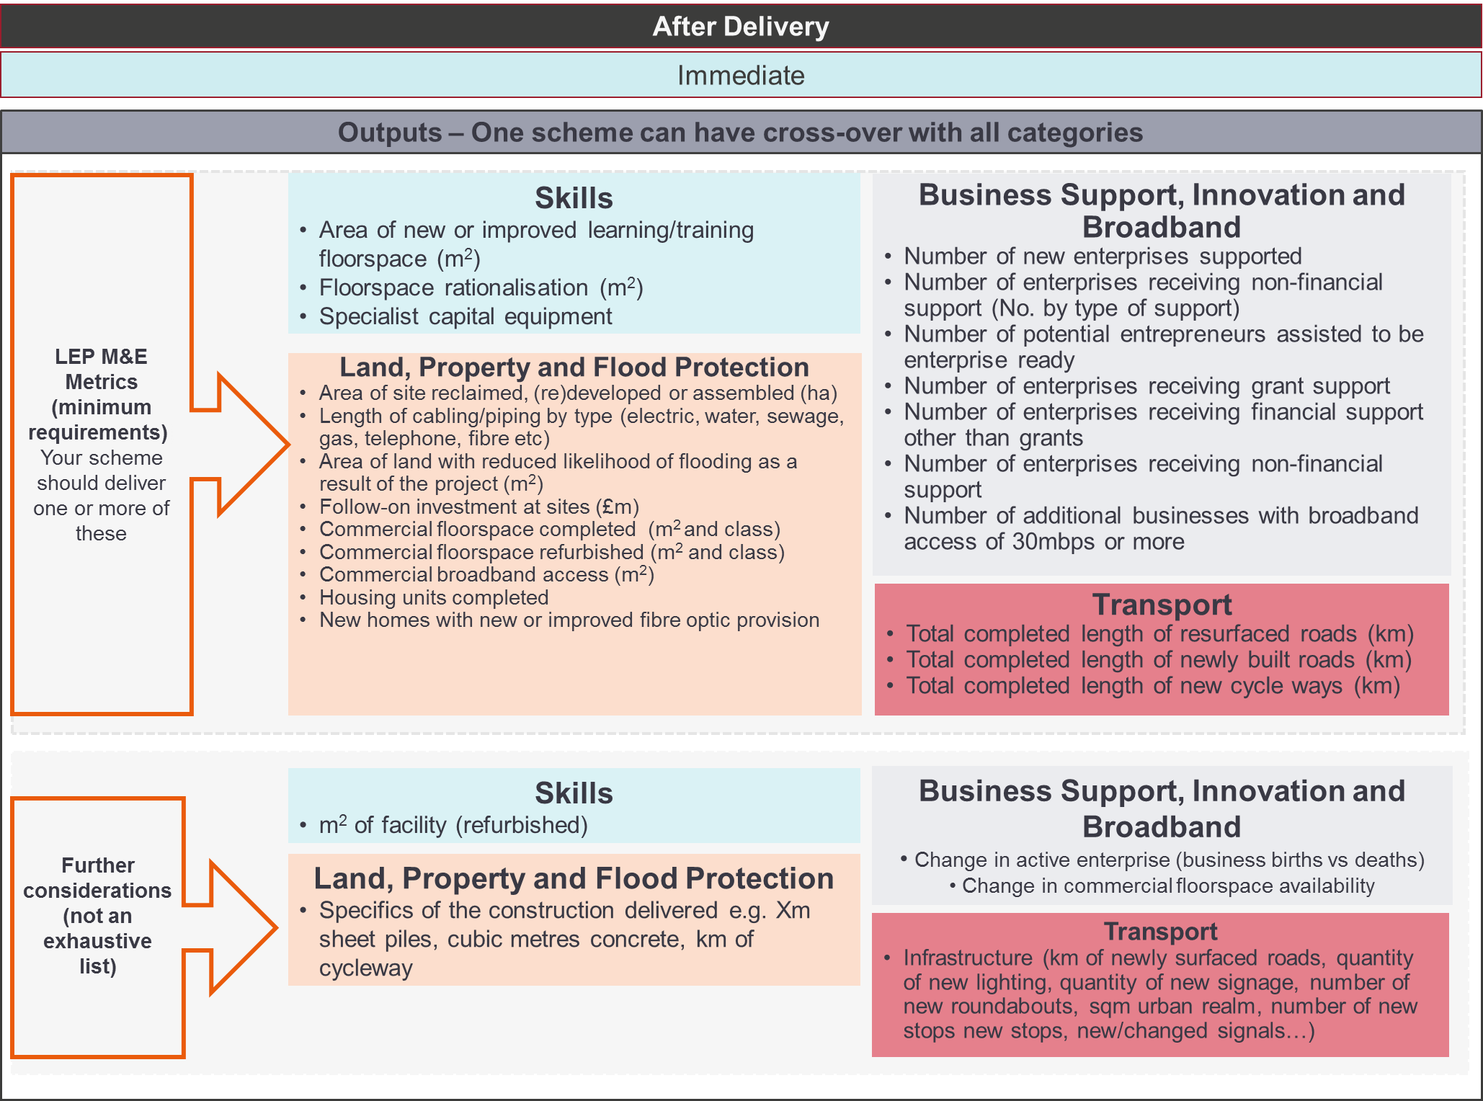
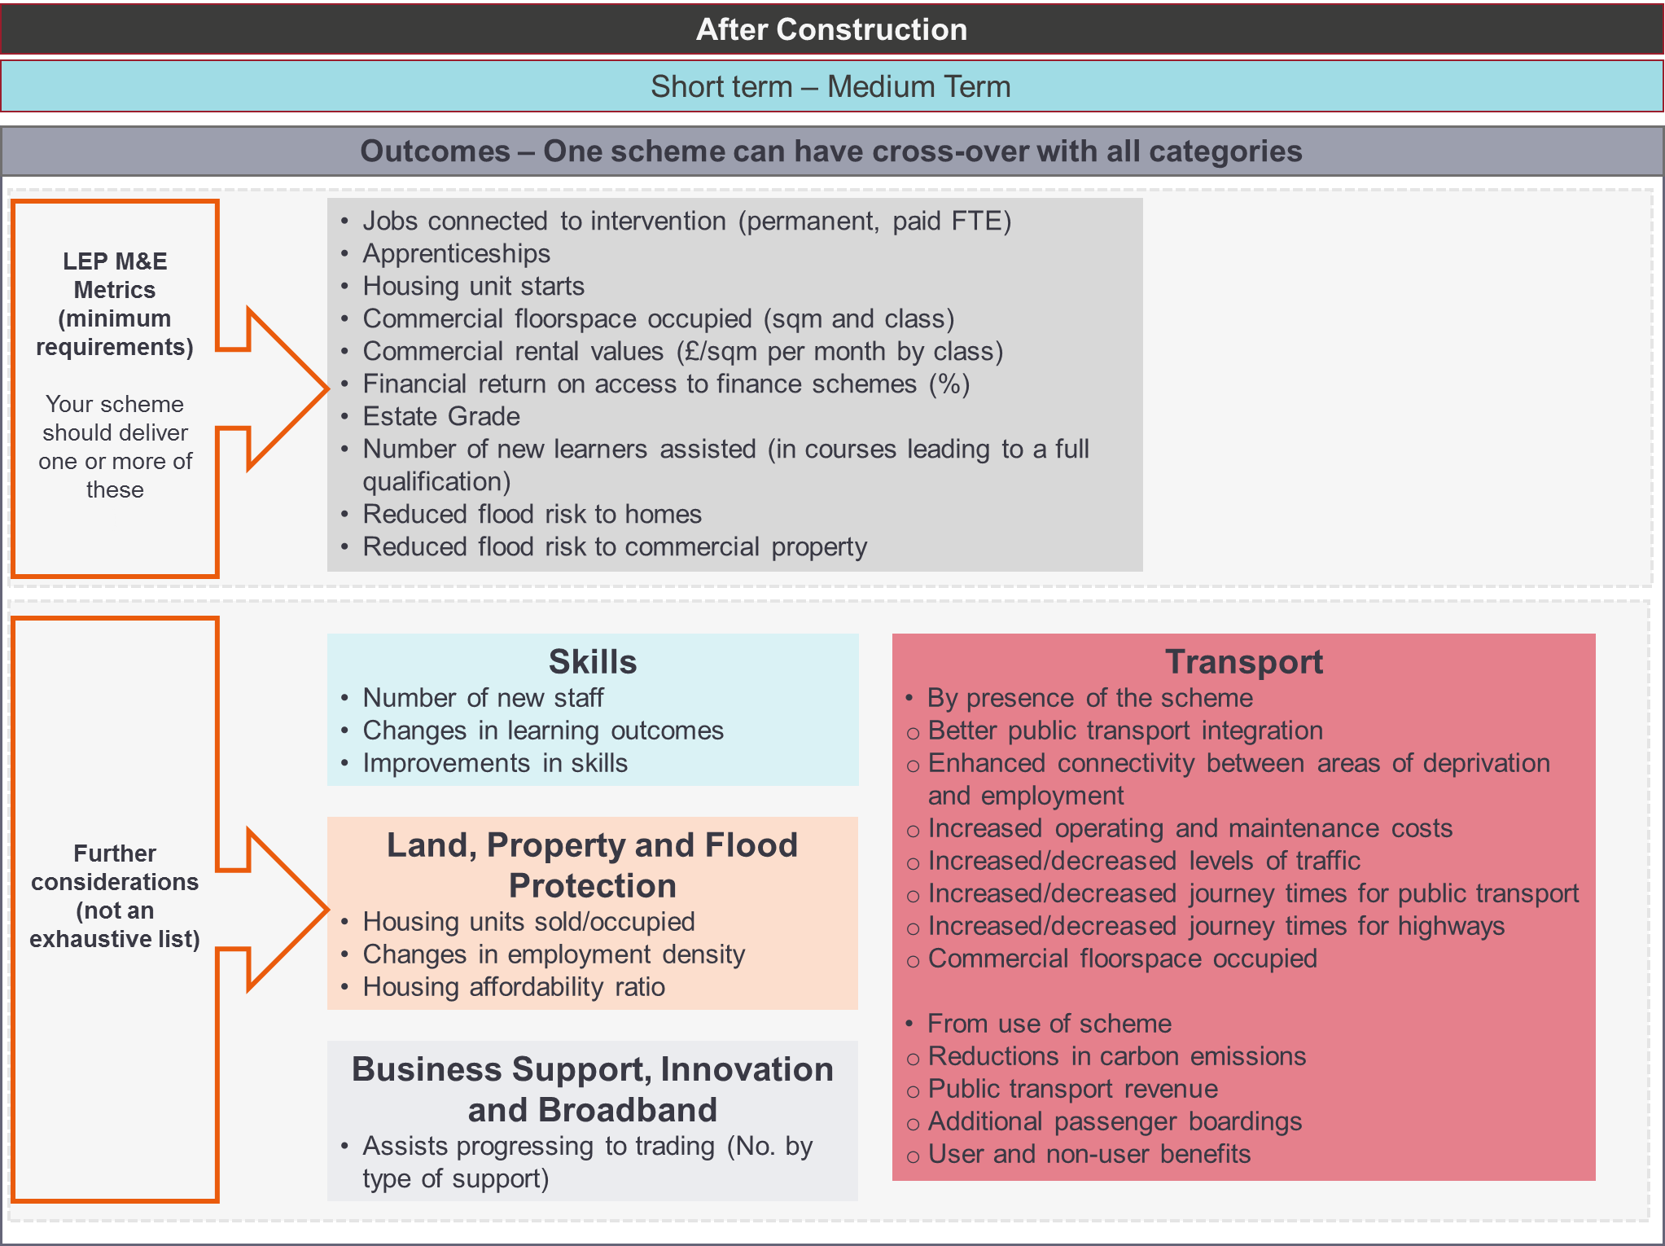
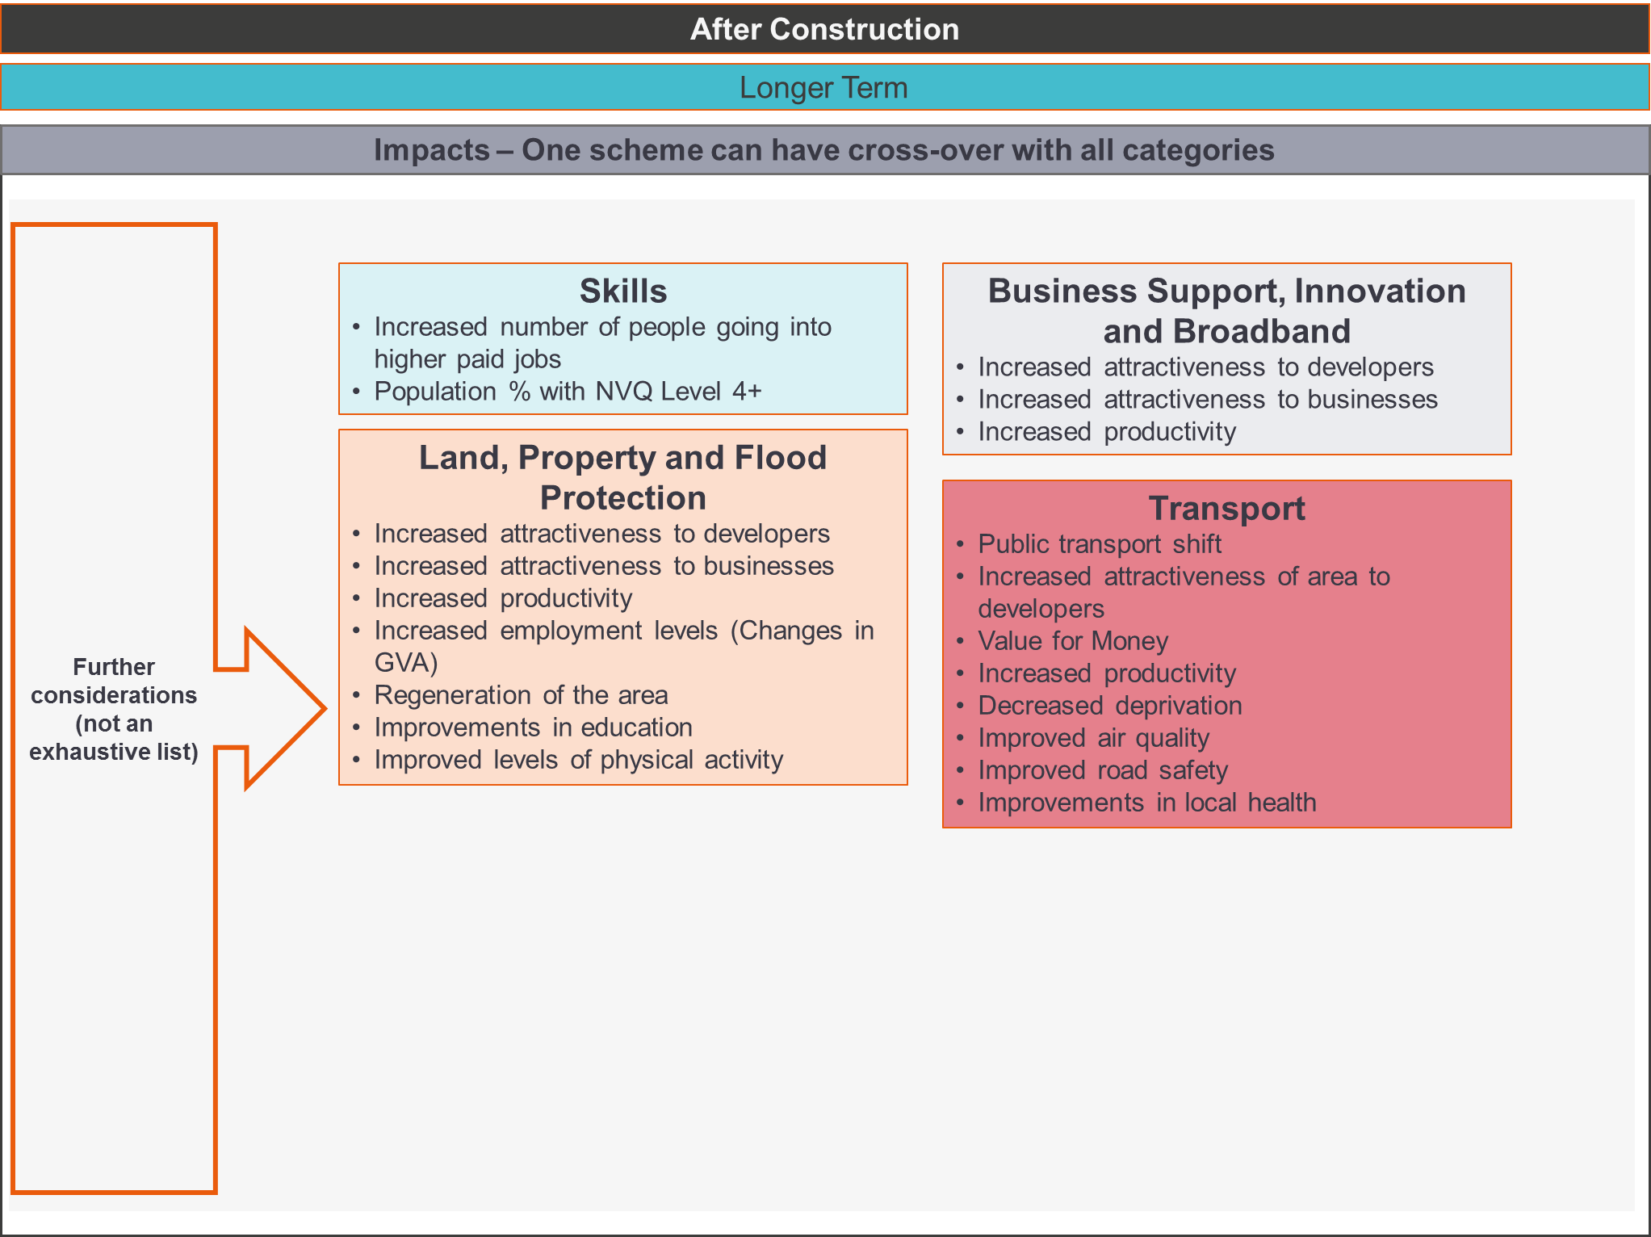

- Appendix E: Monitoring and Evaluation Plan and Baseline Report Templates

monitoring and Evaluation Plan

Purpose
- The Monitoring and Evaluation Plan details what the intended inputs, outputs, outcomes and impacts are of the scheme. These values will most likely come from the Business Case, but may also come from supplementary documentation associated with the scheme.
- The Monitoring and Evaluation Plan details how inputs, outputs, outcomes and impacts will be measured in the One Year After Opening Report and the Five/Three Years After Opening Report and any associated costs.
- The Monitoring and Evaluation Plan also outlines the proposed approach to measuring the baseline information for each of the inputs, outputs, outcomes and impacts and any costs associated with this.
- When the baseline information has been collated, it is reported upon in the Baseline Report template.

A Note on Costs
The Monitoring and Evaluation of a scheme will rely on internal resource and potentially, some external resources. Both could come at a cost either in terms of time or money.

The Monitoring and Evaluation Plan is to be completed as part of the Business Case. At the same time, a Baseline Report would also be completed.

The costs that are anticipated for the collation of the Baseline Report are therefore current costs. However, the costs incurred for data collection for the One Year After Opening Report and Five/Three Years After Opening Report would occur in the future. Therefore, it is important to consider the effect of inflation on these costs.

an Overview to the Monitoring and Evaluation Process
The following provides information on the process for Monitoring and Evaluation and how the reports fit into this process.

Proportionate Approach to completing the report
The GBF supports a wide range of schemes in terms of scope and capital costs.

The Monitoring and Evaluation process has been designed to be aligned to the scale of the scheme based on its total delivery value (including GBF allocations). As a minimum, the number of jobs and housing brought forward by the scheme should be considered. These are factors which the Ministry of Housing, Communities and Local Government (MHCLG) consider to be key outcomes of GBF schemes.

The following is an indicative guide to which inputs, outputs, outcomes and impacts should be included within the Monitoring and Evaluation process for different scales of intervention.

This is based on the scale of the total value of each scheme or the value of a package in totality. Where there are complementary phases of a scheme that are funded at different times, consider establishing the Monitoring and Evaluation for the overall scheme delivered.

Value of Scheme/Package | Inputs | Outputs | Outcomes | Impacts
Under £2m | As described within the report templates | As described within the report templates | Number of jobs and houses delivered | n/a
£2m- £8m | As described within the report templates | As described within the report templates | All those prescribed by the LEP and applicable to the scheme/package (see Appendix A supplied separately)  Also include any additional outcomes that have a large or moderate benefit / disbenefit in the Business Case | Those relevant to the scheme/package from within the list in Appendix A (supplied separately)  Also include any additional impacts that have a large or moderate benefit / disbenefit in the Business Case
More than £8m | As described within the report templates | As described within the report templates | All those prescribed by the LEP and applicable to the scheme/package plus applicable measures from the ‘Further considerations’ section (see Appendix A supplied separately)  Also include any additional outcomes that have a large or moderate benefit / disbenefit in the Business Case | Those relevant to the scheme/package from within the list in Appendix A (supplied separately)  Also include any additional impacts that have a large or moderate benefit / disbenefit in the Business Case

[INSERT Scheme NAME]
This Monitoring and Evaluation Plan provides the details of the inputs, outputs, outcomes and impacts of the [insert scheme name here], how they will be measured, and the costs associated with this for the Baseline Report and One Year After Opening Report and Five/Three Years After Opening Report.

The objectives of the scheme are:
Objective 1
Objective 2
Objective 3

The geography of the scheme is shown in the map below
[insert map(s) of final scheme here]

Inputs
This section requires the scheme promoter to provide information about Scheme Spend, Project Delivery, Project Risk and Project Changes. These are referenced against the values in the Business Case.
- Update the table to include actual Financial Years for the period of delivery and approaches to monitor/track these values
- Note – you may need to extend this table if the funding occurs in a period more than 3 years before your scheme opening date.

ID | Input Description | Source of Value |  | Monitoring Approach | Frequency of Tracking | Source | [FY1/FY2] |  |  |  | [FY1/FY2] |  |  |  | [FY1/FY2]
 |  |  |  |  |  |  | Q1 | Q2 | Q3 | Q4 | Q1 | Q2 | Q3 | Q4 | Q1 | Q2 | Q3 | Q4
IN1 | Grant Spend | Planned / Forecast |  |  |  | Planned/ Forecasted Spend Profile
IN2 | Matched Contributions Spend | Planned / Forecast |  |  |  | Planned/ Forecasted Spend Profile
IN3 | Leveraged Funding | Planned / Forecast |  |  |  | Planned/ Forecasted Spend Profile

Input 4: Project delivery and milestones
- Please complete the table of planned Key Milestones
Milestone | Planned Date of Delivery
Start of project (start spending GBF or match funding)
Public Consultation
Detailed Design
Full Planning Permission Granted
Site Mobilisation Works Commence
Project Completion / Site Opening

Input 5: Risk Mitigation
- Please note any anticipated risks and mitigation [Please refer back to Risk Register in the Business Case].

Outputs
- Please provide information about:
  - The planned/anticipated value for each output with the delivery of the scheme and reference this value from the Business Case or supporting documents
    - How the output will be monitored and evaluated for the One Year After Opening Report – you may need to include maps/diagrams to support this
    - The frequency of data collection related to the output
    - The anticipated cost of undertaking the monitoring and evaluation of the output for the One Year After Opening Report

  - The approach used to obtain baseline information for each output
    - Costs associated with this

EXAMPLE
ID | Output Description
OP1 | Type of service improvement | Details: Planned/Anticipated Output Value and Proposed Approach for Monitoring
Value: 6 minutes from x to y by tram in the morning peak hour

Source of Value: Full Business Case, p10

Future Monitoring Approach: Through public timetable information from scheme opening (July 2021) for tram

Frequency of tracking: Once after opening for One Year After Report

Costs Allocated to Monitoring: Free- from public data source
 |  | Details: Proposed Method of Collecting Baseline Information
Approach for Collection: Review of public transport timetable for equivalent bus route

Costs Allocated: Free- from public data source

Complete and repeat for all Outputs

ID | Output Description
OP1 |  | Details: Planned/Anticipated Output Value and Proposed Approach for Monitoring
Value:

Source of Value:

Future Monitoring Approach:

Frequency of tracking:

Costs Allocated to Monitoring:
 |  | Details: Proposed Method of Collecting Baseline Information
Approach for Collection:

Costs Allocated:

…OP2, OP3, OP4 etc

Outcomes
- Please provide information about:
  - The planned/anticipated value for each outcome with the delivery of the scheme and reference this value from the Business Case or supporting documents
    - How the outcome will be monitored and evaluated for the One Year After Opening Report and for some outcomes, the Five/Three Years After Opening Report as well – you may need to include maps/diagrams to support this
    - The frequency of data collection related to the outcome
    - The anticipated cost of undertaking the monitoring and evaluation of the outcome for reports after opening

  - The approach used to obtain baseline information for each outcome
    - Costs associated with this

EXAMPLE
ID | Outcome Description
OC1 | Jobs connected to the intervention | Details: Planned/Anticipated Outcome Value and Proposed Approach for Monitoring
Value: 30 jobs – 15 from construction and 15 total FTE as a result of the scheme (5 additional jobs delivered in each year after opening for the first three years only)

Source of Value: Full Business Case, p22

Future Monitoring Approach: Construction jobs from contractor’s data. FTEs from surveying new businesses along the route of the tram with a short email questionnaire after scheme opening.

Frequency of tracking: Once after opening and once for five years after opening report

Costs Allocated to Monitoring: £450 for the email questionnaire to be externally delivered for each future report and 1 day of internal resource for mapping responses in GIS. In total £900 but with inflation, this is equivalent to £958+2days of internal resource for both the One Year After Opening Report and Five/Three Years After Opening Report
 |  | Details: Proposed Method of Collecting Baseline Information
Approach for Collection: There is one business in the impact area of the scheme on a small business park which is newly opened. This is a small accountancy firm. An email would be sent to this business to understand the number of people employed there.

Costs Allocated: To send the email and interpret results- £0

Complete and repeat for all Outcomes

ID | Outcome Description
OC1 |  | Details: Planned/Anticipated Outcome Value and Proposed Approach for Monitoring
Value:

Source of Value:

Future Monitoring Approach:

Frequency of tracking:

Costs Allocated to Monitoring:
 |  | Details: Proposed Method of Collecting Baseline Information
Approach for Collection:

Costs Allocated:

…OC2, OC3, OC4 etc

Impacts
- Impacts are often not measurable but can be anecdotal or inferred. However, if they can be measured then an approach and budget should be allocated for this.
- They are a longer-term effect of the scheme being in place and often occur as a result of the outcomes
- They would not be monitored or tracked beyond the Five/Three Years After Opening Report
EXAMPLE
ID | Impact Description
IM1 | Improved road safety | Details: Planned/Anticipated Impact Value and Proposed Approach for Monitoring
Value: General downwards trend in accidents

Source of Value: Full Business Case, p42

Future Monitoring Approach: STATS 19 (Road Accident Statistics)

Frequency of tracking: Annually

Costs Allocated to Monitoring: Free dataset from online but would require 1 day of GIS analysis from internal resource for each report
 |  | Details: Proposed Method of Collecting Baseline Information
Approach for Collection: STATS 19 (Road Accident Statistics)

Costs Allocated: Free dataset from online but would require 1 day of GIS analysis from internal resource

Complete and repeat for all impacts

ID | Impact Description
IM1 |  | Details: Planned/Anticipated Impact Value and Proposed Approach for Monitoring
Value:

Source of Value:

Future Monitoring Approach:

Frequency of tracking:

Costs Allocated to Monitoring:
 |  | Details: Proposed Method of Collecting Baseline Information
Approach for Collection:

Costs Allocated:

…IM2, IM3, IM4 etc

BASELINE REPORT

Purpose
- The Monitoring and Evaluation Plan details what the intended inputs, outputs, outcomes and impacts are of the scheme. It provides details of how they will be measured and any associated costs of the monitoring process.
- The Baseline Report provides information and metrics about the current situation in the impact area of the scheme before delivery commences. Information should be provided for each of the intended inputs, outputs, outcomes or impacts. This baseline data can be used in subsequent stages to identify the scale of change brought about by the scheme.
- The tables in the report provide the basis for a tracking spreadsheet (Benefits Realisation Profile (BRP)) which will be shared with the LEP. The tracking spreadsheet is used to track the baseline, planned/anticipated values and the actual values for every input, output, outcome or impact after the scheme opens.
- The tables in this report include a space for baseline values and for planned/forecast values for each input, output, outcome or impact. These values are likely to come from the Full Business Case, but may also come from supplementary documentation associated with the scheme.

An Overview to the Monitoring and Evaluation Process
The following provides information on the process for Monitoring and Evaluation and how the reports fit into this process.

Proportionate Approach to completing the report
The GBF supports a wide range of schemes in terms of scope and capital costs.

The Monitoring and Evaluation process has been designed to be aligned to the scale of the scheme based on its total delivery value (including GBF allocations). As a minimum, the number of jobs and housing brought forward by the scheme should be considered. These are factors which the Ministry of Housing, Communities and Local Government (MHCLG) consider to be key outcomes of GBF schemes.

The following is an indicative guide to which inputs, outputs, outcomes and impacts should be included within the Monitoring and Evaluation process for different scales of intervention.

This is based on the scale of the total value of each scheme or the value of a package in totality. Where there are complementary phases of a scheme that are funded at different times, consider establishing the Monitoring and Evaluation for the overall scheme delivered.

Value of Scheme/Package | Inputs | Outputs | Outcomes | Impacts
Under £2m | As described within the report templates | As described within the report templates | Number of jobs and houses delivered | n/a
£2m- £8m | As described within the report templates | As described within the report templates | All those prescribed by the LEP and applicable to the scheme/package (see Appendix A supplied separately)  Also include any additional outcomes that have a large or moderate benefit / disbenefit in the Business Case | Those relevant to the scheme/package from within the list in Appendix A (supplied separately)  Also include any additional impacts that have a large or moderate benefit / disbenefit in the Business Case
More than £8m | As described within the report templates | As described within the report templates | All those prescribed by the LEP and applicable to the scheme/package plus applicable measures from the ‘Further considerations’ section (see Appendix A supplied separately)  Also include any additional outcomes that have a large or moderate benefit / disbenefit in the Business Case | Those relevant to the scheme/package from within the list in Appendix A (supplied separately)  Also include any additional impacts that have a large or moderate benefit / disbenefit in the Business Case

[INSERT Scheme NAME]
This Baseline Report provides the details of the inputs, outputs, outcomes and impacts of the [insert scheme name here] from the period [date] to [date], before the scheme is constructed/delivered.

The objectives of the scheme are:
Objective 1
Objective 2
Objective 3

The geography of the scheme is shown in the map below
[insert map(s) of final scheme here]

Inputs
This section requires the scheme promoter to provide information about Scheme Spend, Project Delivery, Project Risk and Project Changes. These are referenced against the information provided in the Monitoring and Evaluation Plan.
- Update the table to include actual Financial Years in the period before opening.
- Monetary values should exclude inflation (nominal values) to easily compare forecast and actual values.
- Note – you may need to extend this table if the funding occurs in a period more than 3 years before your scheme opening date.
- Only the values for spend and leveraged funding will go into the BRP.
ID | Input Description | Source of Value |  | Monitoring Approach | Frequency of Tracking | Source | Year 1 Before Opening [FY1/FY2] |  |  |  | Year 2 Before Opening [FY1/FY2] |  |  |  | Year 3 Before Opening [FY1/FY2]
 |  |  |  |  |  |  | Q1 | Q2 | Q3 | Q4 | Q1 | Q2 | Q3 | Q4 | Q1 | Q2 | Q3 | Q4
IN1 | Grant Spend | Planned / Forecast |  |  |  | Planned/ Forecasted Spend Profile
IN2 | Matched Contributions Spend | Planned / Forecast |  |  |  | Planned/ Forecasted Spend Profile
IN3 | Leveraged Funding | Planned / Forecast |  |  |  | Planned/ Forecasted Spend Profile

Input 4: Project delivery and milestones
- Please complete the table of planned Key Milestones
Milestone | Planned Date of Delivery
Start of project (start spending GBF or match funding)
Public Consultation
Detailed Design
Full Planning Permission Granted
Site Mobilisation Works Commence
Project Completion / Site Opening

Input 5: Risk Mitigation
- Please note any risk mitigation used and if any risks materialised up to the opening of the scheme [Please refer back to Risk Register in the Business Case].

Outputs
- Please provide information about:
  - what the baseline value is for each output and its source;
  - how the baseline value was measured;
  - what the planned/anticipated value is for the output and reference this source; and
  - how the value will be measured after the scheme opens.

EXAMPLE
ID | Output Description |  | Value | Monitoring approach | Frequency of Tracking | Source | Date
OP1 | Type of service improvement | Baseline | 8 minutes from x to y by bus 11 in the morning peak hour | Through public timetable information | n/a | Timetable Bus 11 (March 2018) | March 2018
 |  | Planned/  Anticipated | 6 minutes from x to y by tram in the morning peak hour | Through public timetable information | Once after opening for One Year After Report | Full Business Case, p10 | From scheme opening (July 2021)
Details: Method of Collecting Baseline Information
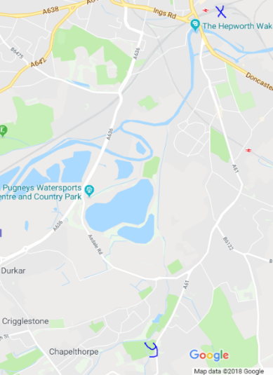
Public transport information from the latest bus timetable for service 11 was reviewed from stop X to Stop Y. The map shows where these locations are.

The cost of collecting this information was £0.

Complete and repeat for all Outputs

ID | Output Description |  | Value | Monitoring approach | Frequency of Tracking | Source | Date
OP1 |  | Baseline
Planned/
Anticipated
Details: Method of Collecting Baseline Information

ID | Output Description |  | Value | Monitoring approach | Frequency of Tracking | Source | Date
OP2 |  | Baseline
Planned/
Anticipated
Details: Method of Collecting Baseline Information

…OP3, OP4 etc

Outcomes
- Provide information about:
  - what the baseline value is for each outcome and its source;
  - how the baseline outcome value was measured;
  - what the planned/anticipated value is for the outcome and reference for this source; and
  - how the value will be measured after the scheme opens.

EXAMPLE
ID | Outcome Description |  | Value | Monitoring approach | Frequency of Tracking | Source | Date
OC1 | Jobs connected to the intervention | Baseline | 10 jobs from one business | Short email questionnaire | n/a | Email questionnaire before opening | 2020
 |  | Planned /  Anticipated | 30 jobs – 15 from construction and 15 total FTE as a result of the scheme (5 additional jobs delivered in each year after opening for the first three years only) | Construction jobs from contractors data. FTEs from surveying new businesses along the route of the tram with a short email questionnaire after scheme opening. | Once after opening and once for five years after opening report | Full Business Case, p22 | After opening
Details: Method of Collecting Baseline Information
There is one business in the impact area of the scheme on a small business park which is newly opened. This is a small accountancy firm. Through an email questionnaire before opening, we found that it employs 10 FTE. The cost of finding out this information was 1 day of internal resource.

Complete and repeat for all Outcomes

 | Outcome Description |  | Value | Monitoring approach | Frequency of Tracking | Source | Date
OC1 |  | Baseline
Planned/
Anticipated
Details: Method of Collecting Baseline Information

 | Outcome Description |  | Value | Monitoring approach | Frequency of Tracking | Source | Date
OC2 |  | Baseline
Planned/
Anticipated
Details: Method of Collecting Baseline Information

…OC3, OC4 etc

Impacts
- Impacts are often not measurable but can be anecdotal or inferred. However, if they can be measured then an approach and budget should be allocated for this.
- They are a longer-term effect of the scheme being in place and often occur as a result of the outcomes.
- They would not be monitored or tracked beyond the Five Years After Opening Report.
EXAMPLE
ID | Impact Description |  | Value | Monitoring approach | Frequency of Tracking | Source | Date
IM1 | Improved road safety | Baseline | 14 slight  7 serious  2 killed | STATS 19 (Road Accident Statistics) | n/a | STATS 19 | 2020
 |  | Planned/  Anticipated | General downwards trend in accidents | STATS 19  (Road Accident Statistics) | Annually | Full Business Case, p42 | By 2026
Details: Method of Collecting Baseline Information
Map STATS19 data and analyse results for key roads and junctions affected by reductions in traffic as a result of the scheme.
This required 1 day of GIS time. STATS19 data was free to use.

Complete and repeat for all impacts

 | Impact Description |  | Value | Monitoring approach | Frequency of Tracking | Source | Date
IM1 |  | Baseline
Planned/
Anticipated
Details: Method of Collecting Baseline Information

 | Impact Description |  | Value | Monitoring approach | Frequency of Tracking | Source | Date
IM2 |  | Baseline
Planned/
Anticipated
Details: Method of Collecting Baseline Information

…IM3, IM4 etc

- APPENDIX F – CATEGORIES OF EXEMPT INFORMATION

There is a clear public interest in publishing information and being open and transparent. But sometimes there is information which we can't publish because it would cause significant harm to the Council - for example by damaging a commercial deal or harming our position in a court case. Equally sometimes publishing information can harm someone who receives a service from us or one of our partners.

The law recognises this and allows us to place information in a confidential appendix if:

(a) it falls within any of paragraphs 1 to 7 below; and
(b) in all the circumstances of the case, the public interest in maintaining the exemption outweighs the public interest in disclosing the information.

  - Information relating to any individual.
  - Information which is likely to reveal the identity of an individual.
  - Information relating to the financial or business affairs of any particular person (including the authority holding that information)
  - Information relating to any consultations or negotiations, or contemplated consultations or negotiations, in connection with any labour relations matter arising between the authority or a Minister of the Crown and employees of, or office holders under, the authority.
  - Information in respect of which a claim to legal professional privilege could be maintained in legal proceedings.
  - Information which reveals that the authority proposes— (a) to give under any enactment a notice under or by virtue of which requirements are imposed on a person; or (b) to make an order or direction under any enactment.
  - Information relating to any action taken or to be taken in connection with the prevention, investigation or prosecution of crime.

